Whas.com

[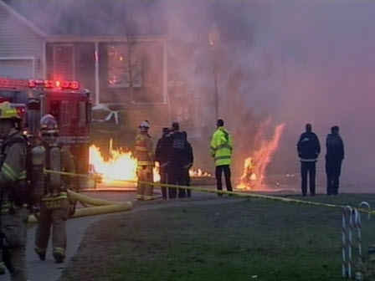](http://www.whas11.com/news/House-fire-and-explosion-in-Okolona-135085793.html?gallery=y&img=1&c=y#gallery-image)

[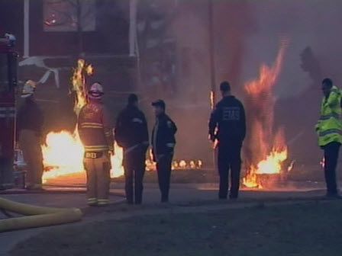](http://www.whas11.com/news/House-fire-and-explosion-in-Okolona-135085793.html?gallery=y&img=2&c=y#gallery-image)

[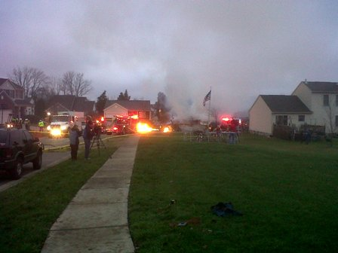](http://www.whas11.com/news/House-fire-and-explosion-in-Okolona-135085793.html?gallery=y&img=4&c=y#gallery-image)

[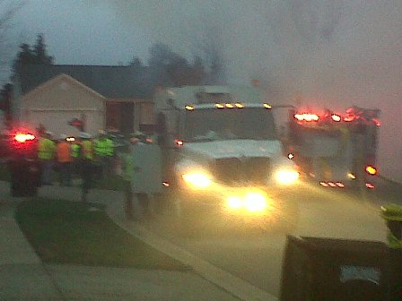](http://www.whas11.com/news/House-fire-and-explosion-in-Okolona-135085793.html?gallery=y&img=5&c=y#gallery-image)

[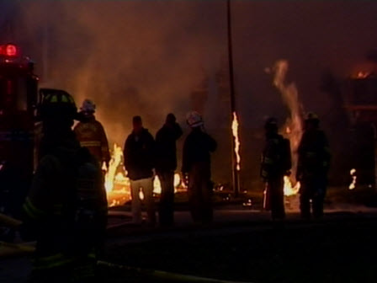](http://www.whas11.com/news/House-fire-and-explosion-in-Okolona-135085793.html?gallery=y&img=7&c=y#gallery-image)

[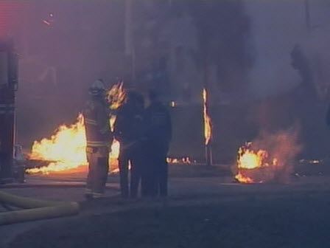](http://www.whas11.com/news/House-fire-and-explosion-in-Okolona-135085793.html?gallery=y&img=9&c=y#gallery-image)

[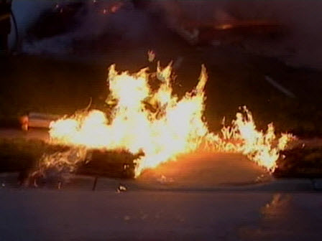](http://www.whas11.com/news/House-fire-and-explosion-in-Okolona-135085793.html?gallery=y&img=10&c=y#gallery-image)

Courier Journal

