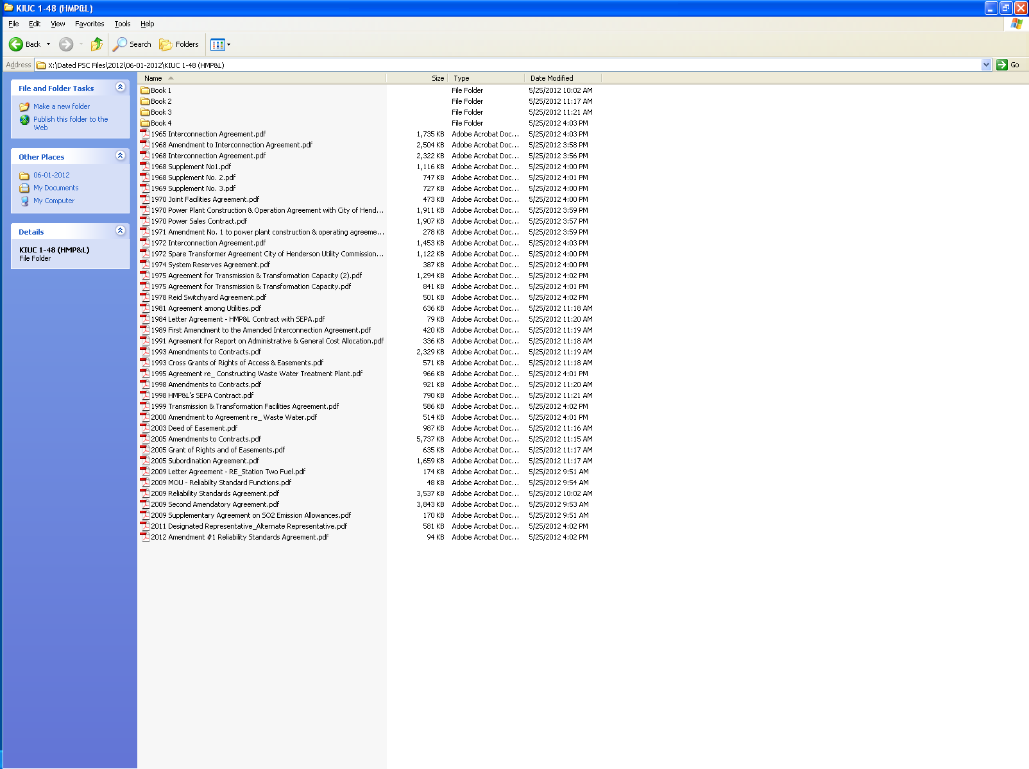

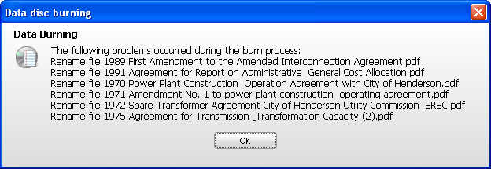
NOTE: Please re-name these files (shorten). The cd burning software changed the names to the following:

1989 First Amendment to the Amended Interconnection Agreemen.pdf
1991 Agreement for Report on Administrative & General Cost A.pdf
1970 Power Plant Construction & Operation Agreement with Cit.pdf
1971 Amendment No. 1 to power plant construction & operating.pdf
1972 Spare Transformer Agreement City of Henderson Utility C.pdf
1975 Agreement for Transmission & Transformation Capacity (2.pdf

