Attorney General Data Request Set 1
Question No. 104
Columbia Gas of Kentucky Respondent: P.R. Moul

BEFORE THE PUBLIC SERVICE COMMISSION OF KENTUCKY
PSC CASE NO. 2007-00008
INFORMATION REQUESTED BY THE ATTORNEY GENERAL
DATED APRIL 10, 2007

Question No. 104

The questions in this section refer to the testimony of Paul R. Moul:

With reference to Appendix I, page I-4, please provide: (1) the methodology employed by Value Line in estimating the “Dividend Yield” and “Median Appreciation Potential,” for the companies followed by Value Line, (2) the dividend yield and appreciation potential data for the individual companies covered by Value Line, (3) copies of the source documents and the dividend yields and projected EPS growth rates for each of the 500 companies in the S&P 500. For (2) and (3), please provide the data in both hard copy and electronic (Microsoft Excel) formats.

Response of Columbia Gas of Kentucky:

- Value Line’s narrative of the “Median Appreciation Potential” as copied from their internet website is provided below.

Updated February 11, 2005

Value Line's 3- to 5-Year Appreciation Potential—An Update
The following is an update to the evaluation of our 3- to 5-year price appreciation potential that was first published on November 8, 2002. That article and accompanying chart detailed the methodology behind our evaluation and discussed some of the more interesting results. For the benefit of our subscribers, we briefly review the methodology used for this, and the previous, evaluation.

Price Appreciation Potential
The estimate of the median price appreciation potential is found by first calculating the percentage change between the current price of each stock in our universe and the middle of its 3- to 5-year Target Price Range. These figures are then arrayed, and the median price appreciation potential is determined. We select the median of the array (the middle) as the most likely price, in order to play down the effect of outliers, that is, excessively large or small percentage price changes.
The chart included below depicts the results of those projections from 1983 to 2004, using the Value Line Arithmetic Index as our measure of the market. For simplicity sake, we take the actual price as the average of the middle year of the 3- to 5-year forecast, so that a projection made at
Attorney General Data Request Set 1
Question No. 104 (Cont’d)
Columbia Gas of Kentucky Respondent: P.R. Moul

the end of 1983 would be compared to the average price of the index in 1987. Strictly speaking this would be a 3 1/2 year forecast, from the end of 1983 to midyear 1987.

Update for 2004

Our estimate for the year 2004 (made at the end of 2000) was 1743. The average price of the Value Line Arithmetic Index in 2004 was 1594. Interestingly, the year ended with the Index at 1796, almost exactly in line with the 4-year projection made in 2000.
The average deviation between the projected and actual average prices was 17% (ignoring signs). The median deviation during this period was 14%.
Our projection for 2008 now stands at 2,425, 38% above the current level.
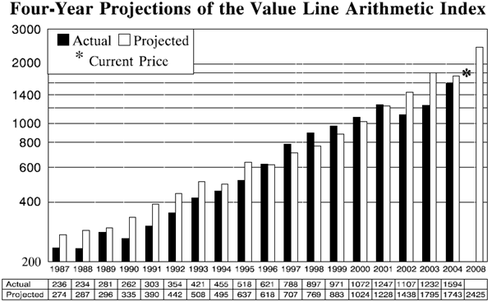

- and (3) The source document provided on page 5 of Attachment PRM-13 was the sole data relied upon by Mr. Moul in his testimony for this purpose. There is no additional data on an individual company basis that was used by Mr. Moul.

