COMMONWEALTH OF KENTUCKY

BEFORE THE PUBLIC SERVICE COMMISSION

In the Matter of:
PETITION OF 1-800-RECONEX, INC. FOR DESIGNATION AS A COMPETITIVE ELIGIBLE TELECOMMUNICATIONS CARRIER PURSUANT TO SECTION 214(e) OF THE TELECOMMUNICATIONS ACT OF 1996 |  | )  )  )  ) CASE NO. 2006-00060  )  )
O R D E R

On February 10, 2006, 1-800-Reconex, Inc. d/b/a U.S. Tel (“Reconex”), a Competitive Local Exchange Carrier, filed with the Commission a petition under 47 U.S.C. § 214(e)(2) seeking designation as an Eligible Telecommunications Carrier (“ETC”) to receive federal universal service support for service offered throughout its service area in the state of Kentucky.
The petition states that: (1) Reconex meets all the requirements for designation as an ETC to serve the designated areas in the state of Kentucky; (2) Reconex requests designation throughout each of the designated areas within its service coverage; (3) in accordance with 47 U.S.C. § 214(e)(2), Reconex is entitled to be designated as an ETC in non-rural wirecenters; and (4) designation of Reconex as an ETC for the designated areas served in Kentucky will serve the public interest.
The Commission seeks comment on Reconex’s petition from affected parties and the general public. The Commission will also set a procedural schedule for this matter.
IT IS THEREFORE ORDERED that:
1. Comments on the application shall be filed within 20 days of the date of this Order.
2. Information requests to Reconex should be filed within 40 days of the date of this Order.
3. Responses to information requests to Reconex should be filed within 60 days of the date of this Order.
4. Requests for a public hearing in this matter should be filed within 75 days of the date of this Order.
5. If no requests for a public hearing are made, parties may file any additional comments on the application and information requests for the Commission to consider within 90 days of the date of this Order.
Done at Frankfort, Kentucky, this 29th day of March, 2006.

By the Commission

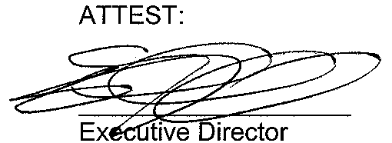

? Reconex requests ETC designation throughout its service area in Kentucky. See Petition at page 1 and Exhibit B.
? Id. at 2.
? Id. at 2 and Exhibit B.
4 Id. at 10.
5 Id. at 11.

