July 15, 2002
Mr. John A. Rogness III
Manager, Management Audit Branch
Public Service Commission, Commonwealth of Kentucky
211 Sower Blvd.
P.O. Box 615
Frankfort, KY 40601
Re: BBC's Review of Kentucky Mountain Power, LLC Site Assessment Report for Proposed Merchant Power Generation Facility in Knott County, Kentucky
Dear John:
BBC's report, Review and Evaluation of Kentucky Mountain Power Site Assessment Report, accompanies this letter. As you suggested last week, we are first submitting the report in electronic, portable document format (PDF) in order to assure compliance with the 30-day review period limitation. We will also place twenty bound and one unbound copies into overnight mail to you, which should arrive at your offices on Wednesday.
BBC looks forward to the forthcoming Board site visit and the Board hearing on this matter next month. Please let us know if you have any questions regarding this report.
Sincerely,
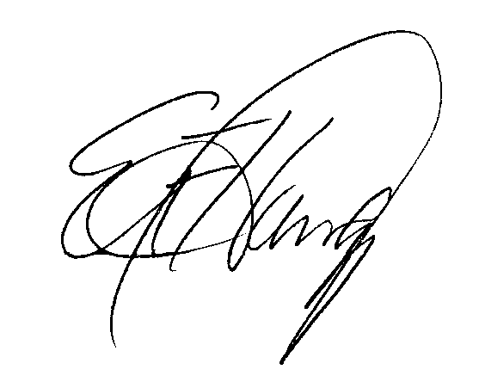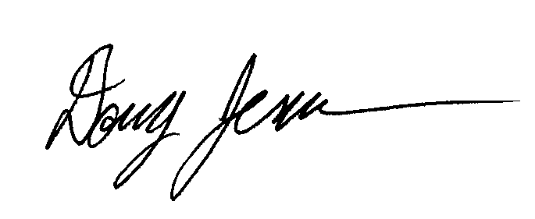
Edward Harvey Doug Jeavons
Managing Director Director

