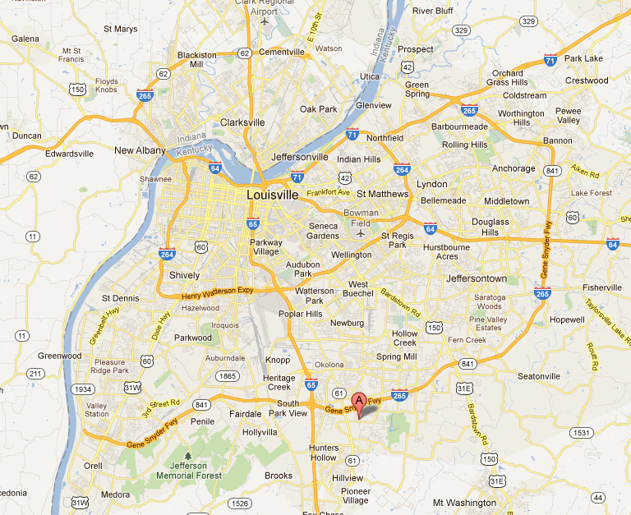

KENTUCKY PUBLIC SERVICE COMMISSION
INCIDENT INVESTIGATION REPORT
5206 River Trail Place
Louisville, Kentucky

