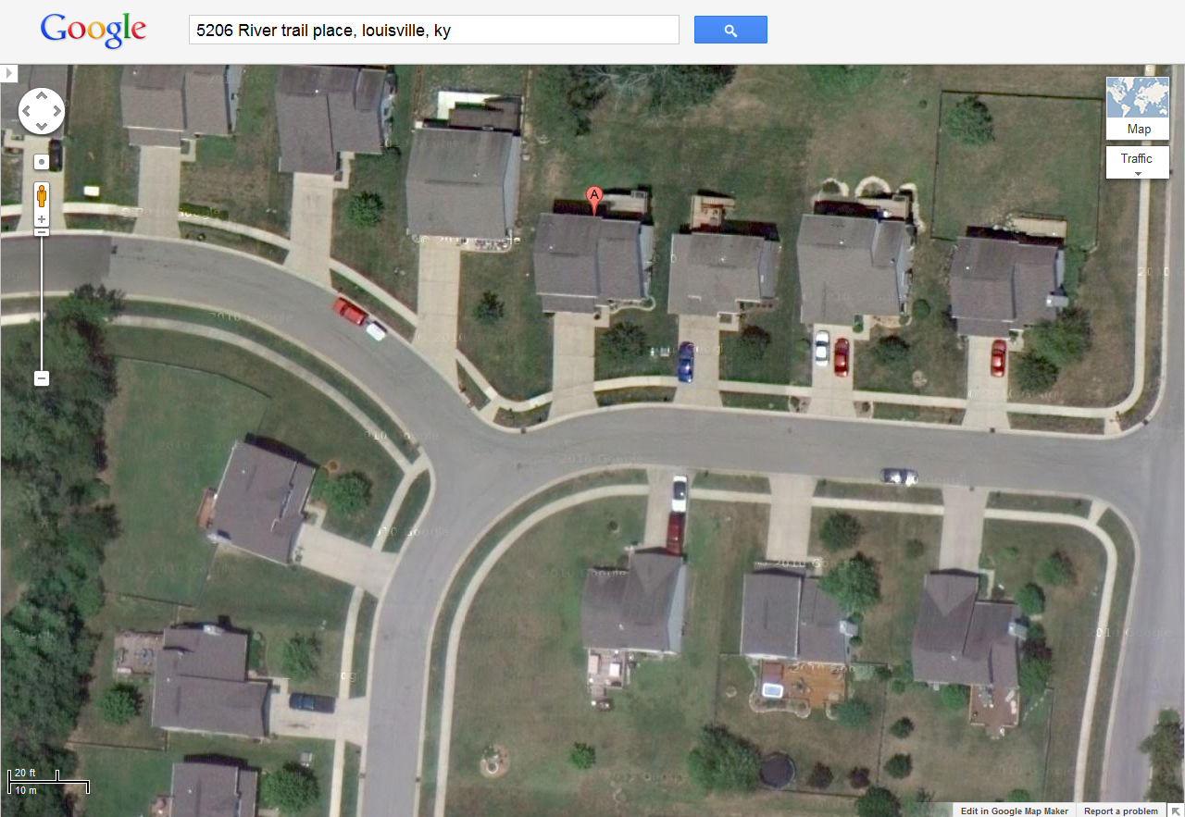
River Trail Place
5206
5131
5133
Natural Gas Line Telephone/Cable/Electric Lines Waterline
Squeeze Off Location Gas Meter Sewer Manhole Storm Drain Water Meter

5202
5204
5200
5201
5203
5207
5210
5212
River Trail Place
Queens Castle Road
4” PMP
4” PMP
2” PMP
NOTE: Drawing is not to scale; all facility locations are approximate.

