Public Service Commission
Electronic Tariff Filing Initiative
Procedures and Guidelines

Revised 11/14/06

Introduction:

The Public Service Commission has implemented a Web-based application for submitting electronic tariff filings, which is intended to streamline the filing process. Please be aware that a paper copy of your filing is still required to be filed with the Commission unless directed otherwise, or until such time as Kentucky statutes are revised to allow acceptance of electronic documents as the official record. Complete instructions on using this e-filing application will be discussed further in this document. First, we would like to address some preliminary information regarding system requirements, notification procedures and electronic document formats.

Web Browser Compatibility / System Requirements and Settings:

This application has been designed to work with Microsoft Internet Explorer, versions 5.5 and 6.0 (with service pack 1). Netscape browsers may not function properly with this application and PSC support for the Netscape product is limited. Therefore, filers are advised to use one of the recommended Microsoft Internet Explorer versions. The minimum recommended computer configuration for this application is a Pentium II processor with 256 megabytes of ram. However, better performance may result from a faster processor and 512 megabytes of ram, depending on the size of documents to be transferred.

The following steps should be taken to ensure correct web browser functionality for executing the E-Filing application:

1. Open your Internet Explorer browser.
Click “Tools” from the top menu bar.
Choose “Internet Options” from the drop-down list.

- Choose the “General” tab.
Click the “Settings” button in the “Temporary Internet Files” section.
Check the box for “Every visit to the page” under the heading of “Check for newer versions of stored pages”.
- Choose the “Security” tab.
Click the button in the lower right corner of the Internet Options window labeled “Default Level”.
(If this setting is already in effect, the “Default Level” button will be disabled.)

- Disable any “Pop-up Blocker” software you may have installed on your computer. This should be controlled by an icon in the “Task Bar” at the bottom of your screen, either by double-clicking or right-clicking on the icon to access the “properties” of the Pop-Up Blocker software.

Notification procedures:

Parties wishing to participate in the electronic tariff filing process, must contact the Commission’s Executive Director in writing, on company letterhead and provide the following information: contact name and e-mail address of the person responsible for tariff filings; tariffed name of the company as filed with the Commission, mailing address, phone and fax numbers.

Upon receipt of your letter, the designated contact person will receive via e-mail, an account/user name and password, to be used for purposes of submitting electronic tariff filings. Please note that for security purposes, the account name assigned for electronic tariff filings will not be the same account name which may have been issued for other electronic filing processes, such as filing of annual report information.

In the event that a password becomes corrupted, lost or otherwise compromised, the method of re-assignment of passwords will be as follows: The party will notify the PSC Tariff Branch via telephone at (502) 564-3940 or e-mail at pscfilings@ky.gov. The PSC Tariff Branch will cause a new password to be generated, then notify the party via e-mail, at the e-mail address on record. As a security measure, passwords will not be transmitted by telephone.

We hope that you will choose to participate in this new tariff filing system and welcome any feedback that you may wish to provide. For questions or comments regarding use of this system, please contact the PSC Tariff Branch at (502) 564-3940 (e-mail: pscfilings@ky.gov).

Document format:

Electronically filed tariffs must be of Adobe Acrobat portable document format (PDF) and should be searchable. This can be accomplished by one of the two following methods: Installation of “Adobe Acrobat” software enables MS Word or WordPerfect documents to be ‘printed’ to ‘PDF’ format, creating a searchable output document. As an alternative, scanned documents may be converted to searchable ‘PDF’ by processing the scanned images through ‘Adobe Acrobat’ software, which converts the image contents to a searchable ‘PDF’ formatted document. There are other software products, which create ‘PDF’ documents, however Commission staff is only familiar with operation of the Adobe product.

All “PDF” files should be “optimized” for viewing over the Internet. When a non-optimized ‘pdf’ document is accessed via the Internet, the browser attempts to download the entire document before displaying any of the text. For large documents or slow Internet connections, this can result in an extremely long wait period before the document will open. To address this performance issue, documents should be “optimized” for efficient downloading. When optimized, the browser will start displaying the first page as it is downloaded, allowing the user to begin reading the document shortly after the download starts, while the remainder of the document finishes downloading in the background. See the companion document titled “Optimizing PDF Documents” for complete instructions on the optimization process.

As a research aid, parties should include “bookmarks” at significant locations within Tariff documents. It is recommended that each primary section within a tariff be bookmarked for easy access. Creation of “bookmarks”, are a feature of the Adobe Acrobat software and may be created with very little effort on the part of the preparer.

When possible, filers should make every reasonable effort to limit the size of individual documents, within a filing, to a maximum size of approximately 5 megabytes. This suggested size limitation is made in order to accommodate processing by persons having dial-up Internet connections, as one objective of electronic filing is to make information readily available to the general public through our web site. Also, larger file sizes may require the filer’s computer to be configured with additional memory.

Parties wishing to file electronic tariffs of extremely large size not conducive to electronic transfer, may, with the permission of the Commission, deliver those documents on CD. However, an accompanying electronic filing must be submitted containing a reference within a cover letter document to the fact that a CD was delivered at the time of delivery of the required paper copy.

Enforced limitations on electronic document filings are as follows:
- Maximum number of documents per filing = 20
- Maximum total document size per filing = 100 megabytes
3. Recommended maximum individual document size is 5 megabytes

Document Naming Conventions:

The following general document naming conventions should be followed. Proposed deviations from these conventions should be brought to the attention of the PSC Tariff Branch for consideration, as to adding them to our published standards. Document names must not contain spaces or any special characters, other than an “underscore” or “hyphen”, therefore, we suggest using the “underscore” character in lieu of a space character within a document name.

The following general naming conventions should be followed and include the following parts:

- Company abbreviation prefix followed by the letters “TRF”
(Example: = BST_TRF = Bellsouth tariff filing.)
- Subject of the document.
(Example: Access_Charges = Document contains “Access Charges”)
- Date which document was filed, formatted as mmddyy.
(Example: 042100 = April 21, 2000).
- Document name extension.
(Example: “.pdf” = Adobe Acrobat portable document format)

In addition to the primary tariff documents to be filed, each filing must be accompanied by one additional document named “Read1st.pdf”. This document should contain any information such as may typically be included in a filing cover letter, including reference to any materials not included in the electronic filing, along with a statement attesting that the electronically filed documents are a true representation of the original documents to be filed with the Commission.

A few examples follow:

BST_TRF_Read1st_022404.pdf = Cover letter document.
BST_TRF_Access_Charges_022404.pdf = Access Charges section of tariff.
BST_TRF_Change_Pages_10-15_022404.pdf = Revised pages ten through fifteen.

Connecting to the PSC Electronic Filing System:

Parties will connect to the PSC Electronic Filing Center through the Commission’s web site at http://psc.ky.gov/pschome.htm and follow the links for “Tariffs” / “Electronic Tariff Filing” / “Submit Electronic Tariffs”, which will connect the user to the PSC Web Portal as in the example below.

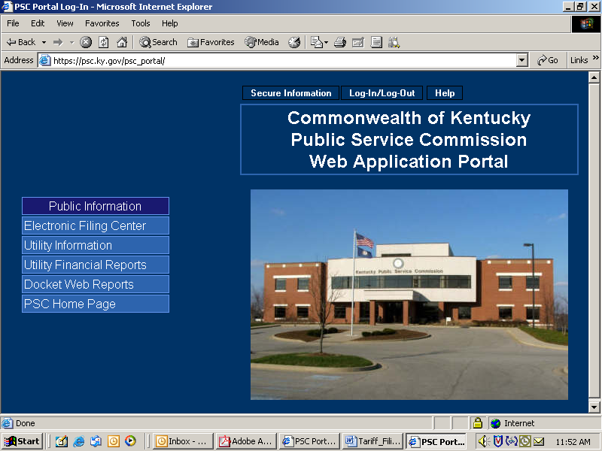

The PSC Web Application Portal will be the primary point of access for most Commission information, which is acquired by automated systems. This document will only focus on submitting electronic tariff filings, however you will see from the menu above that additional Utility and Docket-related information may be also accessed from this source.
Submitting Electronic Tariff Filings:

In order to submit electronic tariff filings, the filer must obtain an account ID and password, using the procedures discussed above in the “Notification Procedures” section. After obtaining your electronic tariff filing account and password, please proceed using the following instructions:

Connect to the PSC Electronic Filing Center as described in the section titled “Connecting to the PSC Electronic Tariff Filing System” on page 6, which direct you to the PSC web portal pictured below.

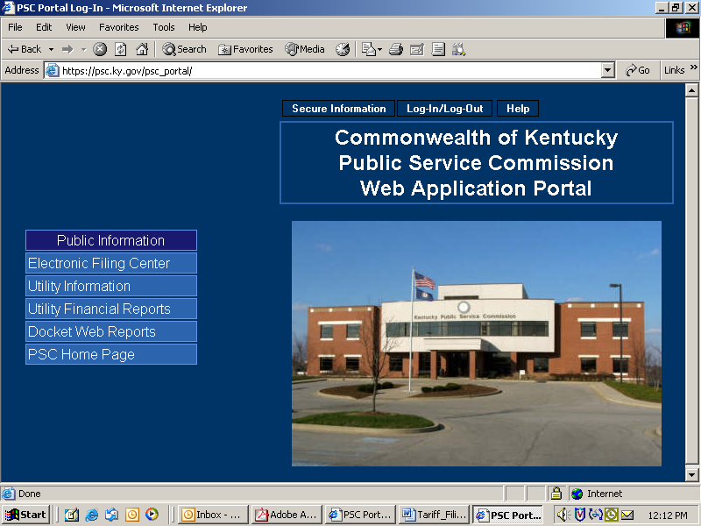

Click the “Log-in (Authorized Personnel Only)” selection on the Web Portal menu bar as in the example below:

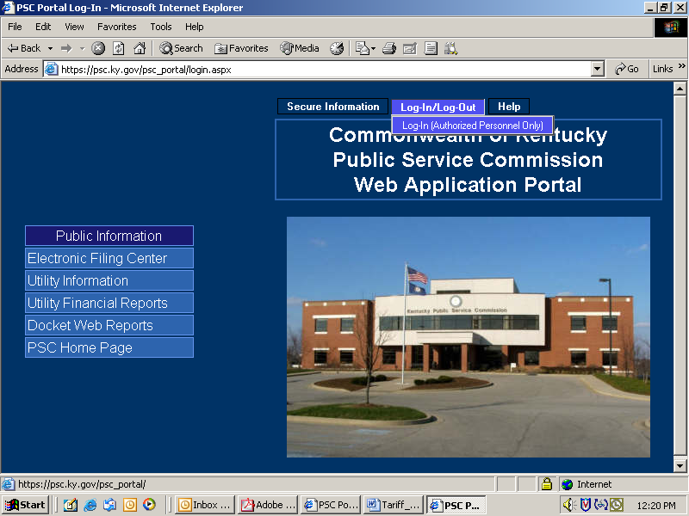

You will receive the following login window:

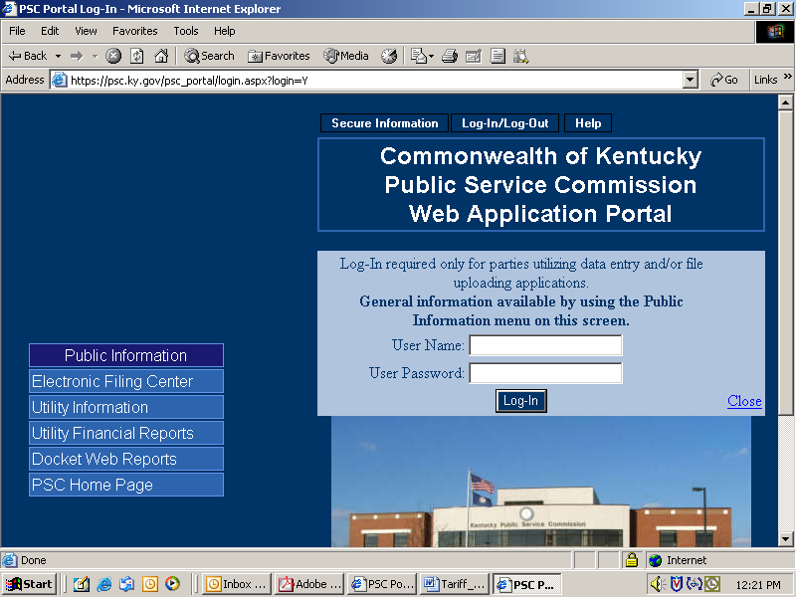

Enter your assigned User Name and Password in the spaces provided. Passwords are case sensitive and must be entered exactly as they appear in your notification e-mail. If you decide not to log in, please click the “Close” link in the lower right corner of the login window.

Upon a successful login, choose the “Tariff Filing” selection from the “Secure Information” menu. See example below:

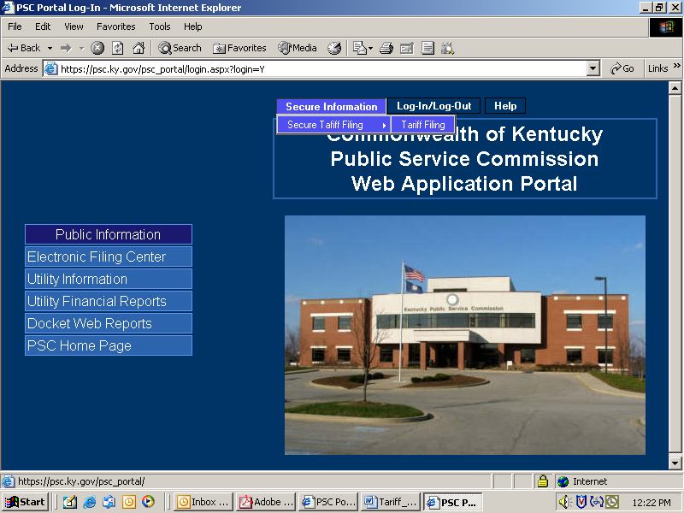

The “Tariff Filing” menu selection will place you at the “Electronic Filing Center” web page displayed below. Proceed to submit electronic tariff filings by choosing the “Tariff Upload” selection under the “Services” menu. See example below:

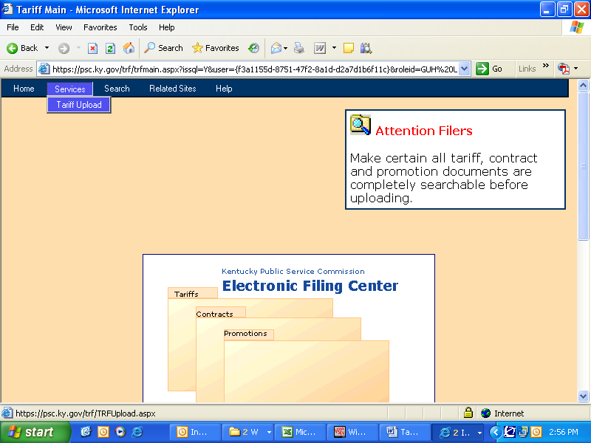

The next window to appear will depend on whether or not you have any previously submitted filings for which an amendment or change is expected.

If an amended filing is expected, you will see a window similar to the following example, wherein you may choose the appropriate tariff number link to proceed with submitting an amendment to a previous filing or simply choose the link labeled “New Filing” to conduct a new tariff filing.

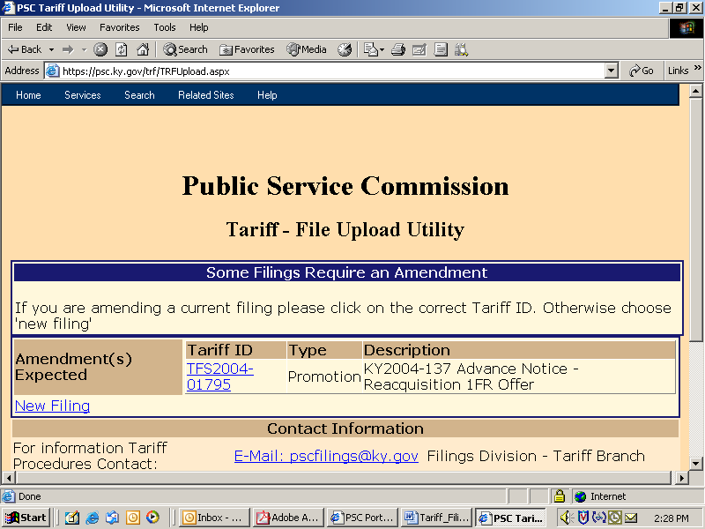

After choosing a to submit an amended filing, a new filing, or if there are no previous filings flagged for expected amendments, you will be presented with a window similar to the following two-part example:

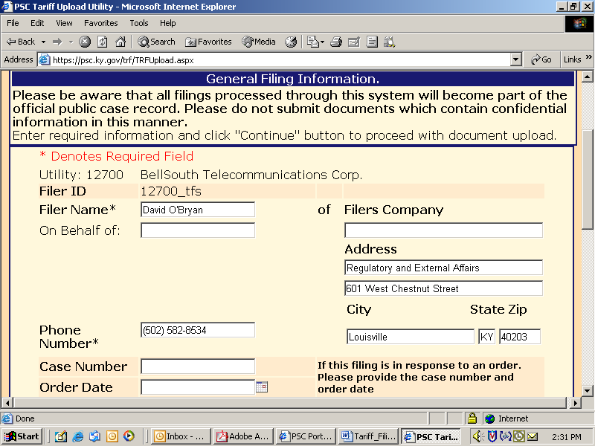

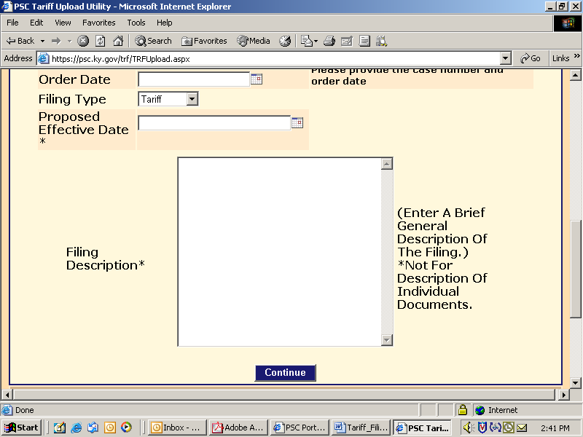

This window will be pre-loaded with certain information from previously filed tariffs or information based on our filing ID. You may change any information as necessary and proceed to enter the remaining required fields. Following is a brief explanation of each data entry box:

Filer Name: Enter the name of the individual conducting the filing session.
Filer’s Company / Address: Name and address of the filing entity. May be different from the company associated with the filing ID, as with a law firm or consultant filing for a utility.
On behalf of: Denotes that a filing was conducted on behalf of someone else, as with an attorney or consultant filing for a utility manager.
Phone Number: Enter as (555) 555-5555
Case Number / Order Date: If this filing is the result of a PSC Order, please provide the relative case number and order date.
Filing Type: Select from three available choices – Contract, Tariff or Promotion
Proposed Effective Date: Enter as mm/dd/yyyy
Filing Description: Enter a brief summary of the purpose of this filing.

After entering the required information, choose the “Continue” button to proceed to the next window.
Your screen will be refreshed with a window similar to the following example:

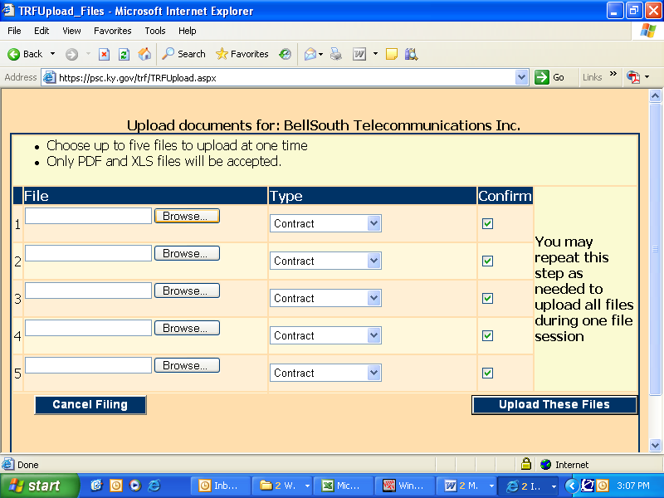

Click on the “Browse” button to navigate among your local computer or network drives to choose the documents to be uploaded.

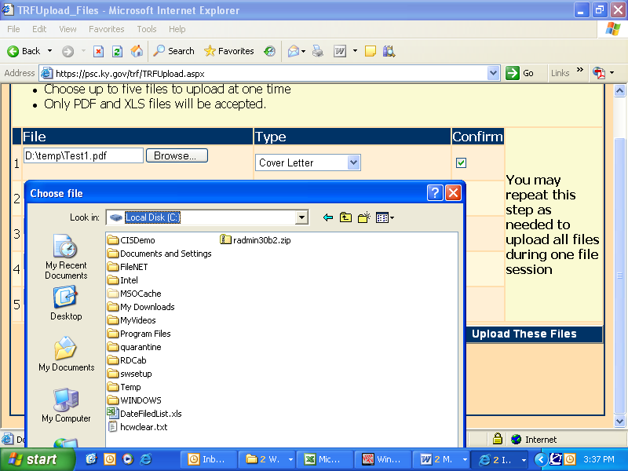

Please note that the upload filter only allows you to select “pdf” (Acrobat) files as discussed in the previous “Document Format” section.

After navigating to the desired folder, select document(s) to be uploaded by single-clicking on each document name, then click the “Open” button at the bottom of the “Choose File” window.
Your selected files will now appear as in the example screen below:

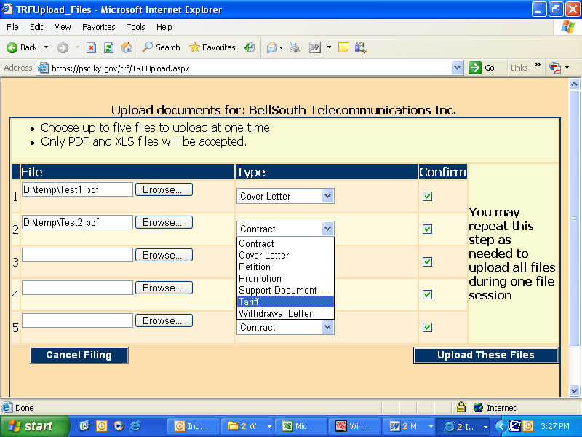

Important: For each document to be uploaded, please click in the “Description” column to select from a pre-defined list of document descriptions.

Note: If you have included a document which you wish not to be uploaded, simply clear the corresponding “Confirm” check box to the right of the document name. Only documents having a check mark in their corresponding “Confirm” box, will be uploaded.

To upload the selected documents, click the button labeled “Upload These Files” located at the lower right corner of the upload window.

You may cancel the entire filing by pressing the “Cancel Filing” button at the lower left corner of the upload window.
After the initial batch of documents have been uploaded, the user will be presented with an informational message advising that they may upload additional documents or press the “Complete Filing” button, in order to finalize the transaction.

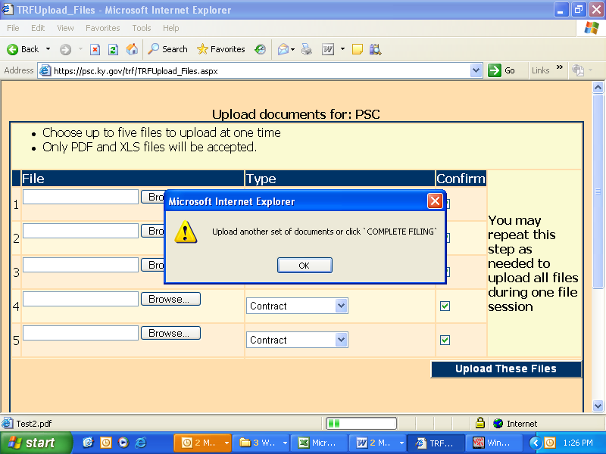

Failure to press the “Complete Filing” button will result in failure of the entire tariff filing transaction.

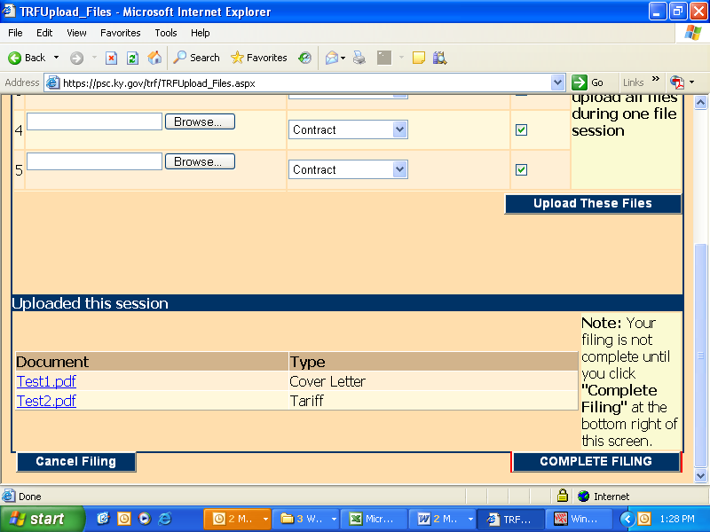

Patience is required when using this system via a “dial-up” modem connection or when uploading extremely large documents. Dial-up users should be aware that a typical “56K” modem connection usually yields no more than a 40,000 bits per second (4,000 characters per second) transfer rate. Therefore, uploading documents of one megabyte (1 million characters) in size could take nearly 5 minutes to complete. Also, a poor quality phone line may result in failure to complete the document transfer process.

This electronic filing system works best using a high-speed Internet connection such as DSL, cable modem or T1.
After your files have been transferred, you should receive the following confirmation screen. You should print and save a copy of this screen as proof that your files were submitted, along with the automated e-mail response you will receive from pscfilings@ky.gov

Important: Please print this confirmation screen or your confirmation e-mail message and attach it to the front of the required paper copy. The printed confirmation will inform our Tariff Branch staff that the documents are associated with a previously electronically filed tariff.

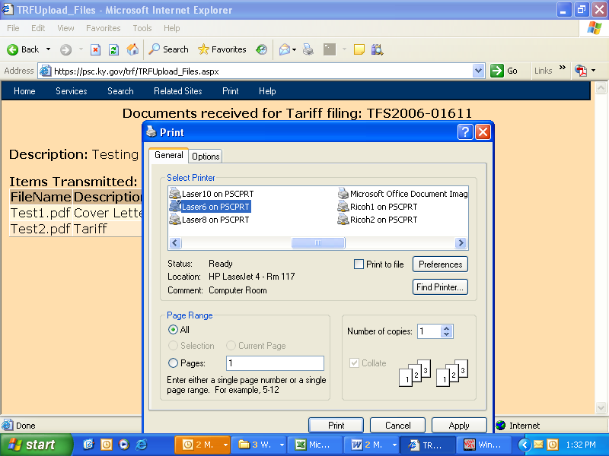

After circulation, review and approval within the PSC, you should receive a follow-up e-mail indicating that your filing was “posted” into our “Electronic Tariff Library”, which contains a complete record of all approved tariffs on file with the Kentucky PSC.

If document(s) were rejected for any reason, it will be so indicated in the e-mail message. You should retain all confirmation messages, as part of your filing documentation.

Exit your electronic filing session by closing your web browser or use the browser’s “Back” button to initiate a new filing session.
Monitoring the status of tariff filings:

You may monitor the status of electronically filed tariff documents by using the search feature within our filing portal. Electronic tariff filings are identified as either “circulating”, (meaning they are presently under review by Commission staff), or “closed” (meaning that the filing has been reviewed and approved or rejected). After satisfactory review, tariff filings are inserted into the appropriate “master” tariff documents located at http://www.psc.ky.gov/tariffs .

Please note that it is not necessary to “log-in” to the system in order to monitor the status of a tariff filing.

Review the status of an electronic tariff filing by entering the web portal as described earlier within this document, then position your cursor on the portal link labeled “Electronic Filing Center”, as in the sample window below:

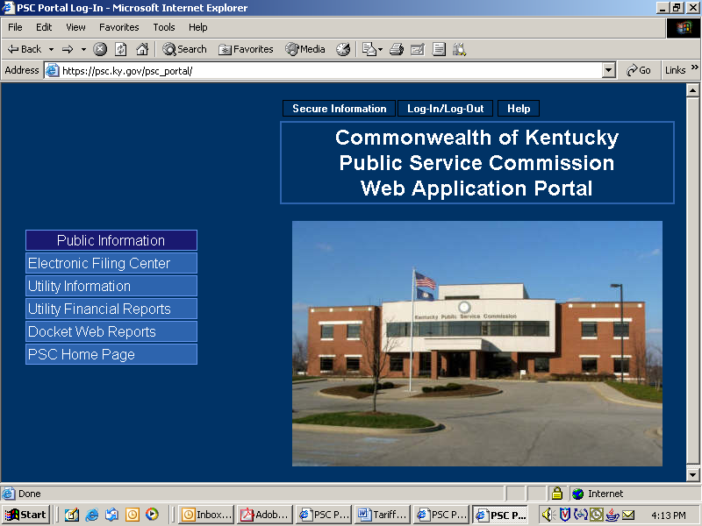

Next, click on the selection for “Electronic Tariff Filing” as in the sample window below:

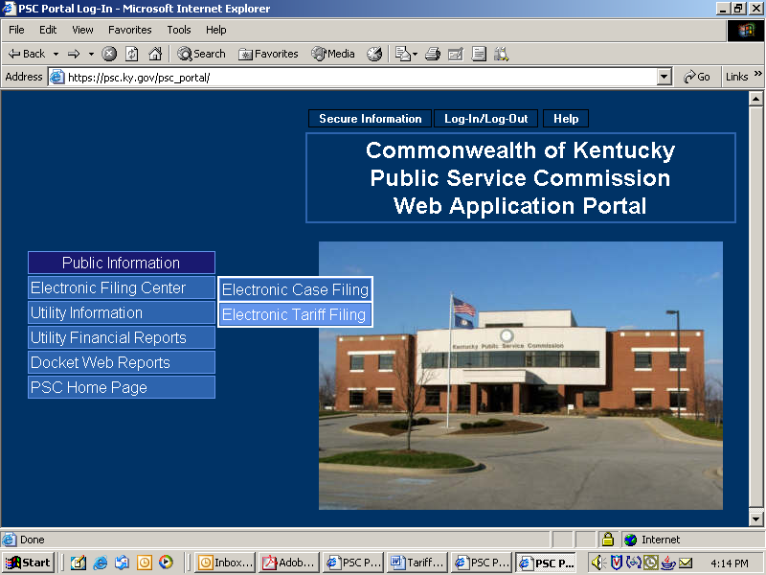

You will then be presented with a window as in the sample below. You may choose from the two options under the menu item labeled “Search”.

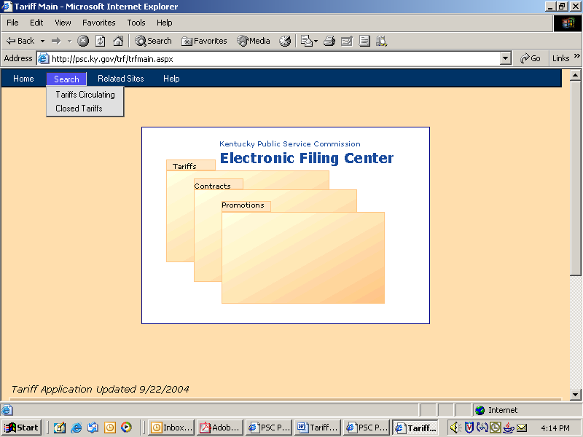

Monitor “Circulating” Tariff filings:

Choosing the option labeled “Tariffs Circulating” will present a search window, as in the sample below, which allows searching for specific circulating tariffs based on multiple criteria.

A default listing of all circulating tariffs is also provided at the bottom pane of the window, organized by groups of ten per page and presented in alphabetical order. You may navigate among the pages by choosing the “Next” and “Previous” symbols located at the lower right of the search criteria area.

Limit your search for circulating filings by using the search criteria as shown in the sample window below.

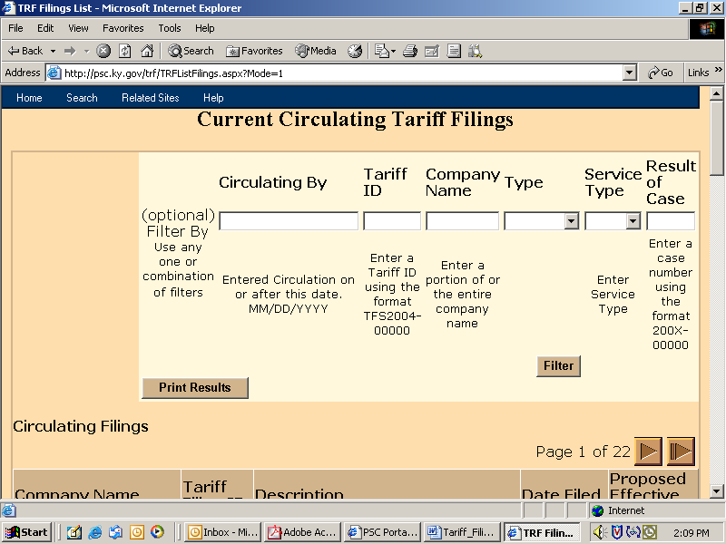

You may use one, or any combination, of available search criteria, as further described below:

Circulation By: This filter accepts a date value, (in the format of MM/DD/YYYY), and will return all filings in circulation on or after the specified date.

Tariff ID: The Tariff ID is an internal tracking number assigned to each transaction as it is entered into our computer system. E-mail messages generated at the time of initial filing will contain a reference to the unique Tariff ID and should be retained for future reference. Enter the Tariff ID in the format of “TFS”, followed by the four digit year, followed by a hyphen, then the sequence number. Example: “TFS2005-00001” or “TFS2005-1”.

Note: You may enter only the sequence number and the system will assume the current year and correct the entry into the proper format as it executes the search.

Company Name: Enter any portion of a filing company name. Entering “bell” will return hits for Bellsouth, Bell Atlantic, Cincinnati Bell, etc.

Type: Choose the appropriate filing type from the drop-down menu. Choices are “Tariff”, “Contract” or “Promotion”.

Service Type: Choose from available utility service types of Electric, Gas, Sewer, Water, or Telecommunications.

Result of Case: If the filing is in response to a Commission Order, you may specify the associated docket case number in the proper format of four digit year, hyphen, and five digit sequence number. Case number information is also available from our web site, under the links for “Docket Information” and “PSC Orders”. Example: 2005-00001

Execute your search by clicking the button labeled “Filter”, located at the bottom of the search criteria window. Results will be returned in the lower half of the search window.
Monitor “Closed” Tariff filings:

The term “closed” as used in this context, refers to the status of a filing which has completed the internal review process and incorporated into the official company tariff, or denied / rejected due to specific issues.

Choosing the option labeled “Closed Tariffs” will present a search window, as in the sample below, which allows searching for specific closed tariffs based on multiple criteria.

A default listing of all closed tariffs for the current year is also provided at the bottom pane of the window, organized by groups of ten per page and presented in alphabetical order. You may navigate among the pages by choosing the “Next” and “Previous” symbols located at the lower right of the search criteria area.

Limit your search for closed filings by using the search criteria as shown in the sample window below.

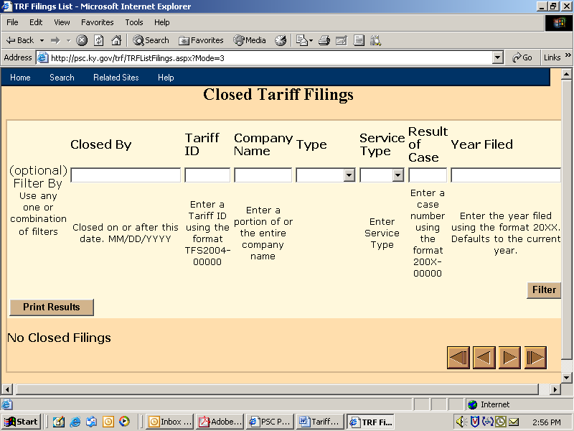

You may use one, or any combination, of available search criteria, as further described below:

Closed By: This filter accepts a date value, (in the format of MM/DD/YYYY), and will return all filings closed on or after the specified date.

Tariff ID: The Tariff ID is an internal tracking number assigned to each transaction as it is entered into our computer system. E-mail messages generated at the time of initial filing will contain a reference to the unique Tariff ID and should be retained for future reference. Enter the Tariff ID in the format of “TFS”, followed by the four digit year, followed by a hyphen, then the sequence number. Example: “TFS2005-00001” or “TFS2005-1”.

Note: You may enter only the sequence number and the system will assume the current year and correct the entry into the proper format as it executes the search.

Company Name: Enter any portion of a filing company name. Entering “bell” will return hits for Bellsouth, Bell Atlantic, Cincinnati Bell, etc.

Type: Choose the appropriate filing type from the drop-down menu. Choices are “Tariff”, “Contract” or “Promotion”.

Service Type: Choose from available utility service types of Electric, Gas, Sewer, Water, or Telecommunications.

Result of Case: If the filing is in response to a Commission Order, you may specify the associated docket case number in the proper format of four digit year, hyphen, and five digit sequence number. Case number information is also available from our web site, under the links for “Docket Information” and “PSC Orders”. Example: 2005-00001

Year Filed: Due to the large number of closed tariff filings, the results are presented one year at a time, with the default being the current year. You may enter a previous year value to view records of filings for the specified year.
Please use the four digit year format.

Execute your search by clicking the button labeled “Filter”, located at the bottom of the search criteria window. Results will be returned in the lower half of the search window.
Producing reports:

You may produce a report of information gleaned from the search mechanism by choosing the button labeled “Print Results”, located at the lower left corner of the search criteria window.

This function will format your search results into an Adobe formatted (PDF) document for display within a separate browser window. From this window, you may choose to save the report to a “pdf” document located on your local computer and/or print the report to your local printer. You may also use the “search” feature within the browser to find text contained within the report.

The sample report below contains an example of “Tariffs Circulating”, as filed by Bellsouth.

